**Installation of Jenkins in WINDOWS**

Pre-request to install Jenkins:

* Java 7 or above version
* Note: To check the Java version in the Windows Machine type the following command in command prompt.

java -version

* If the Java version is not found in your system then open the Power shell as admin mode and run the following command to install the Java.

choco install jdk11

or

<https://www.oracle.com/java/technologies/javase-jdk11-downloads.html>

Note: After the installing the Java you have to set the Path in environment variables

Installation of Jenkins:

Download the LTS version for windows from <https://www.jenkins.io/download/>

* After installation completed extract the zip file and you can find the Jenkins.msi file, double click on that to start the installation.
* Just follow the installation steps shown in the window.
* After installation was completed Jenkins will be open the browser.
* You can see the below page in the browser.

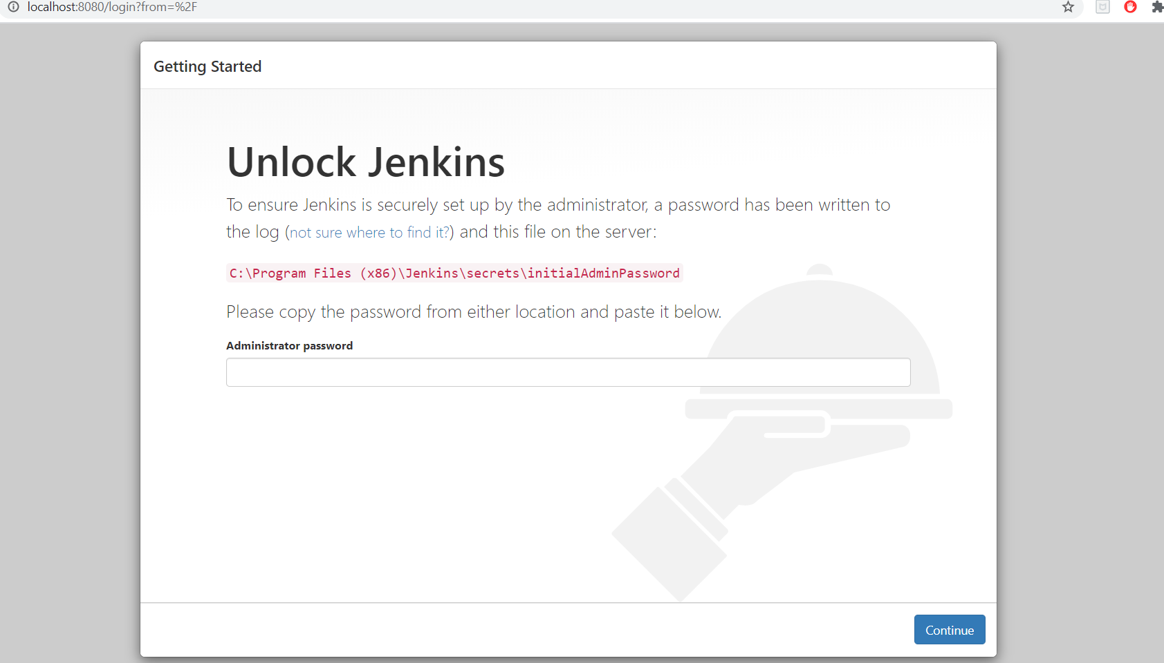

* To unlock the Jenkins you need Administrator password. And this password is set in this directory.

C:\Program Files (x86)\Jenkins\secrets\initialAdminPassword

* Just paste the path in the file explorer and open with the notepad. You can find a key in the text file, just copy that one and paste it in browser. And the click on the continue button.

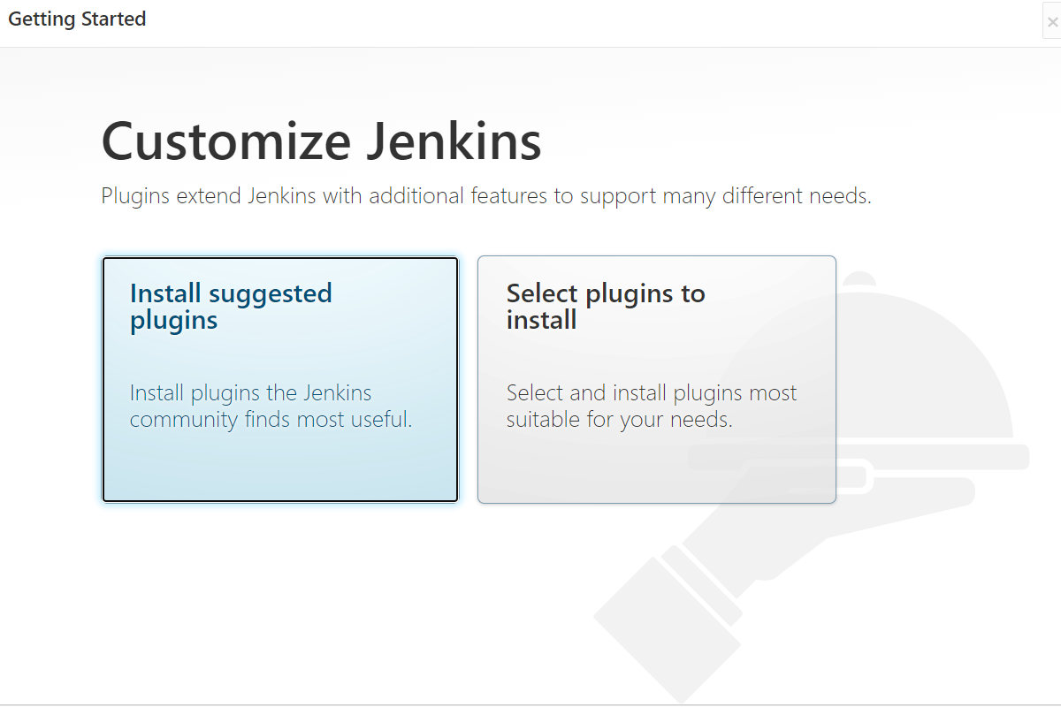

* Click on the Install suggested plugins.
* You can see the below image. It will take the time to install. Don’t worry if the any plug-in installation fails.

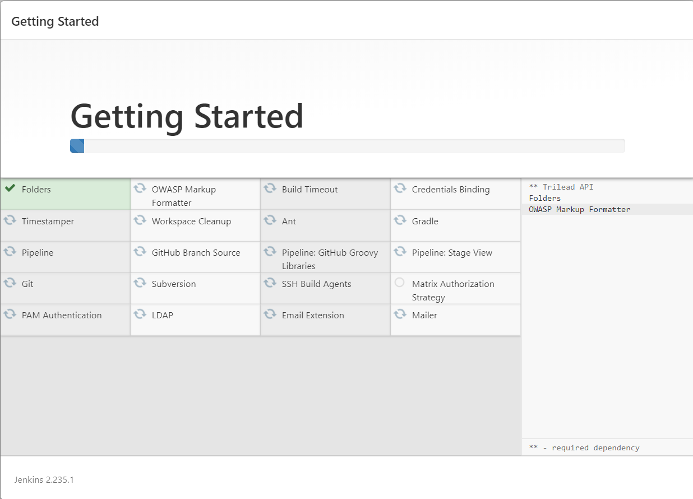

* After installation completed click on the continue button, you can navigate to another screen.

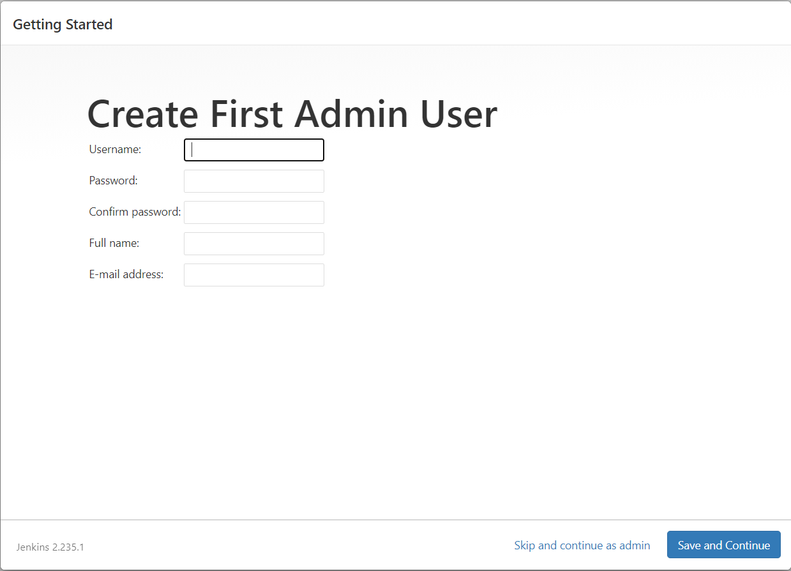

* Enter the details and click on Save and continue button. And then click on save and finish.
* You can find the below screen.

